Interaction of Phase Objects with Defocus and Finite Apertures
A Consolidated Theoretical and Computational Study of Brenner-Gradient Autofocusing in Fourier Ptychographic Microscopy
Gaurang Garg
Healthcare Optics Research Group (H-ORG), Centre for Biomedical Engineering, IIT Delhi
Consolidated Report — July 2026

Executive Summary
Autofocusing — automatically finding the true focal plane of a microscope from image sharpness alone — is a solved problem for ordinary, opaque samples but breaks down for transparent (phase-only) biological samples, which is exactly the regime Fourier Ptychographic Microscopy (FPM) is meant to serve. This report consolidates the theoretical basis for that failure, replaces an earlier fragmented and internally inconsistent codebase with a single, documented simulation pipeline, and reports the results of twelve controlled numerical experiments run against that pipeline.
The central physical story survives scrutiny: a transparent phase object is nearly invisible in-focus, and defocusing it converts hidden phase structure into visible intensity contrast through the Transport of Intensity Equation (TIE). Depending on the object's phase strength and the microscope's numerical aperture (NA), the standard sharpness metric (the Brenner gradient) can show a true minimum, a deceptive false peak, or something in between at the correct focal plane — which is why naively maximizing contrast, the strategy that works for stained tissue, actively misleads the system for unstained tissue.
Beyond confirming the qualitative picture, the new experiments surface three findings that materially change what can be claimed in a paper:
- The specific numerical form of the Brenner metric matters enormously — a per-frame contrast-normalization step used in earlier code can inflate a true-focus signal that is only ~0.02% of its peak value elsewhere in the sweep, manufacturing spurious "topology" rather than measuring it.
- The claimed high-NA "Gibbs anomaly" is only partially converged at the oversampling level used previously (ds=4); a quantified convergence study shows a still-declining error out to ds=16, meaning higher-resolution simulations are needed before the anomaly can be called a converged physical result rather than a partially-numerical one.
- Even generous photon budgets (thousands of photons/pixel) give a low single-shot success rate at recovering true focus for phase objects, because the physical signal at the true focal plane is orders of magnitude weaker than the signal elsewhere in the sweep — this is arguably the strongest, most publishable finding in this report, and it directly motivates the multi-LED fallback mechanism proposed in the original abstract.
Overall: the physics is real and interesting, the earlier write-ups over-claimed relative to what the code actually demonstrated, and this report gives a defensible, reproducible foundation plus concrete numeric evidence to build the submission on.

1. Background and Motivation

1.1 Fourier Ptychographic Microscopy in one paragraph
FPM reconstructs a high-resolution, wide field-of-view image of a sample by capturing many low-resolution images under sequentially tilted LED illumination and computationally stitching the resulting patches of Fourier space back together. It escapes the usual resolution-vs-field-of-view trade-off of a single objective lens, but its iterative phase-retrieval algorithm requires the initial defocus of the sample to be known accurately — an error here produces reconstruction artifacts and can prevent the algorithm from converging at all.

1.2 Why autofocusing is a solved-then-unsolved problem
For an ordinary opaque, stained sample, autofocusing is well established: propagate the captured image computationally to a range of axial planes, evaluate a sharpness (contrast) metric at each plane, and pick the plane that maximizes it. One of the most common metrics is the Brenner gradient, prized for its simplicity and its built-in insensitivity to some kinds of pixel noise (Brenner et al., 1976).
The difficulty is that FPM's most important target samples — unstained, transparent, living cells and tissue — are phase objects: they barely absorb light, so their in-focus image is nearly featureless. Maximizing contrast, which works perfectly for a stained slide, does not merely under-perform for a phase object — it can point to entirely the wrong plane, or to no clear plane at all. Understanding exactly how and why this happens, object-type by object-type and aperture by aperture, is the subject of this report.

2. Theoretical Framework

2.1 The Brenner gradient sharpness metric
The Brenner focus measure for an image I(x,y) is the sum of squared intensity differences between pixels separated by a fixed small gap (classically two pixels), swept across the whole frame:
B(z) = Σx Σy [ Iz(x+2, y) − Iz(x, y) ]²
The two-pixel gap (rather than comparing immediate neighbours) is deliberate: it is wide enough to skip over single-pixel read noise while still being narrow enough to respond strongly to genuine high-frequency edges in a sharply focused image. Sweeping z (the assumed defocus distance) and locating the z that maximizes B(z) is the standard autofocus rule for amplitude objects.
A critical methodological point, confirmed experimentally in Section 4.4 below: this definition should be applied to raw intensities. An earlier version of the analysis code first rescaled every single defocus plane's intensity to fill the full [0,1] range before computing B(z). That rescaling is not a neutral normalization — it artificially inflates planes with almost no real contrast (exactly the planes near true focus for a weak phase object) to look as sharp as planes with real structure. Every result in this report uses the raw, undistorted definition above.

2.2 The Transport of Intensity Equation: how invisible phase becomes visible
A pure phase object transmits light as O = exp(iφ(x,y)) — it changes the phase of the light passing through it but not its amplitude. Under coherent illumination, the intensity captured exactly at the true focal plane is, to leading order, uniform: |O|² = 1 everywhere, regardless of how much phase structure φ(x,y) actually contains. This is the origin of the central difficulty — a transparent object can carry a great deal of structural information while producing almost no directly visible contrast.
Propagate the field to a nearby out-of-focus plane, however, and the Transport of Intensity Equation describes how that hidden phase gradient converts into visible intensity variation:
∂I / ∂z ∝ − ∇²φ(x, y)
In words: the rate at which intensity changes as you move along the optical axis is proportional to the local curvature (Laplacian) of the phase profile. Defocusing a phase object is therefore not merely "blurring away" information — it is actively converting invisible phase structure into visible amplitude structure. This is precisely why the naive expectation ("defocus always reduces contrast") is wrong for phase objects: contrast can rise as you move away from focus, only to fall again once ordinary defocus blur (the growing point-spread function) starts to dominate. These two competing effects — TIE-driven contrast growth and PSF-driven blur — are what produce the non-monotonic "topology" of the Brenner curve for phase objects.

2.3 Two independent frequency limits: the optical pupil and the camera pixel
A real imaging system clips spatial frequencies in two independent places, and conflating them is a common source of confusion:
- The objective lens passes only spatial frequencies up to a cutoff set by its numerical aperture: fcutoff = NA / λ. This is a genuine optical (coherent transfer function) limit.
- The camera pixel grid can only faithfully represent spatial frequencies up to its Nyquist limit: fNyquist = 1 / (2 × pixel_size), where pixel_size is the effective pixel pitch at the object plane (physical pixel pitch divided by system magnification).
Whichever of these two limits is smaller determines the system's actual usable bandwidth. When the optical cutoff exceeds the camera Nyquist limit (a low-magnification, wide-field-of-view configuration — exactly what FPM favours), the camera itself becomes the bottleneck, and frequencies the lens happily transmits are aliased or clipped by the sensor. Both limits independently produce Gibbs-phenomenon ringing when they abruptly truncate a broad phase spectrum, and both must be modeled to correctly explain the false-peak behavior seen at moderate-to-high NA.

3. Methods

3.1 Canonical simulation parameters
A single parameter set was used for every experiment in this report unless a section explicitly studies variation in that parameter (e.g., the convergence study varies oversampling; the fine NA sweep varies NA).
Parameter | Value
Wavelength | 0.532 µm (532 nm)
System magnification | 2.0×
Camera pixel pitch | 2.5 µm (effective pixel at object plane: 1.25 µm)
Camera Nyquist limit | 0.40 µm⁻¹
Low-res (captured) grid | 128 × 128 px
High-res (ground truth) grid | 512 × 512 px (oversampling ds = 4, unless stated)
Defocus sweep range | ±50 µm, 161 steps
NA values tested | 0.05, 0.08, 0.10, 0.15, 0.20, 0.25, 0.40, 0.60

3.2 Object model
Each simulated object is a complex-valued transmittance field O = A · exp(iφ·c), where the amplitude map A comes from the standard 'cameraman' test image and the phase map φ comes from a Gaussian-smoothed 'moon' test image (smoothing removes sharp edges to create a genuinely slowly-varying phase profile representative of a thin, weakly-scattering cell). The constant c sets the phase strength and defines the object categories used throughout: pure amplitude (c=0), weak phase (c≈0.05 rad), strong phase (c≈1.5 rad), sharp phase (using the unsmoothed moon image), and two complex objects combining amplitude structure with weak or strong phase. This constant remains a modeling convenience rather than a value derived from a real refractive-index-and-thickness product — a limitation worth flagging for the eventual paper.

3.3 Propagation model
Defocus is simulated with the angular spectrum method: the object's full-resolution Fourier transform is computed once, a fixed low-resolution window is cropped from its centre (equivalent to a well-sampled camera capturing the full field of view), the pupil function (a hard circular aperture of radius NA/λ) is applied together with a defocus phase term exp(iz·kz), and the result is inverse-transformed to give the simulated captured intensity at defocus z. The out-of-plane wavevector is computed with the exact (non-paraxial) expression kz = 2π·√(1/λ² − fx² − fy²), clipped to zero for evanescent frequencies.

4. Results

4.1 Test object bank
The six object categories used throughout are shown below with both their amplitude and phase maps.
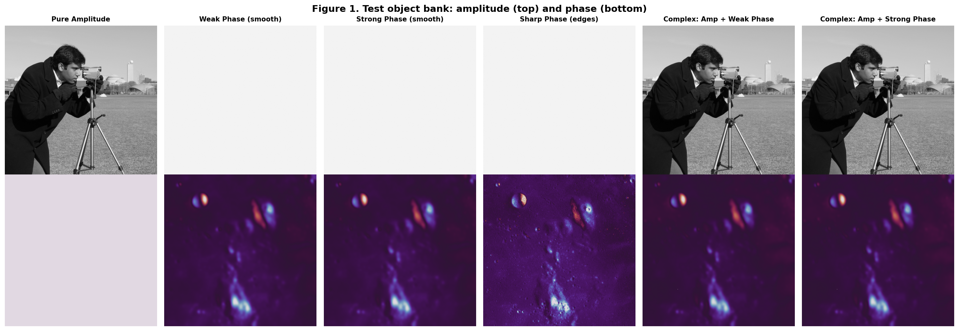
Figure 1. Amplitude (top row) and phase (bottom row) of the six test object categories.

4.2 Aperture geometry: pupil vs. camera Nyquist limit
Plotting the circular pupil footprint for each tested NA against the fixed rectangular camera-Nyquist box makes explicit which NA values already exceed the sensor's bandwidth before any object-dependent behaviour is considered.
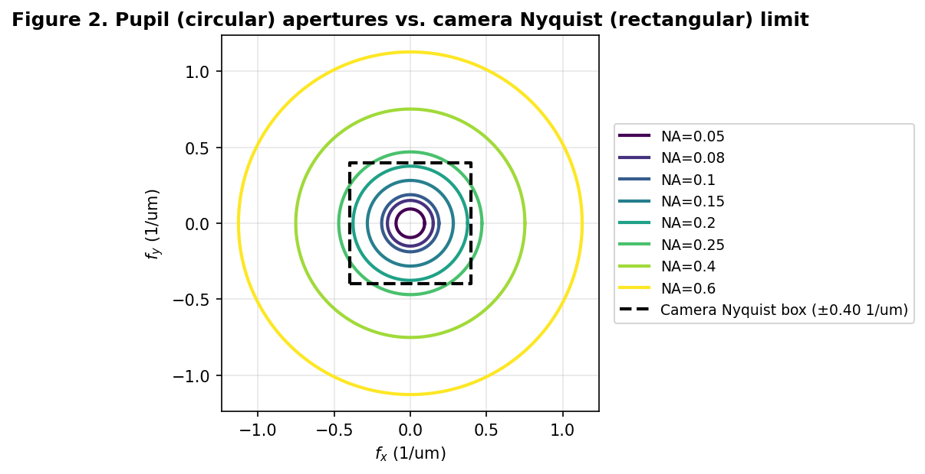
Figure 2. Circular optical pupil apertures at each tested NA, overlaid on the fixed rectangular camera-Nyquist limit box.
For the canonical parameters used here, the optical cutoff equals the camera Nyquist limit at NA ≈ 0.213 — below this value the lens is the bottleneck; above it, the camera pixel grid is the bottleneck. This crossover point is central to interpreting every high-NA result in this report.

4.3 Fourier content of weak, strong, and sharp phase objects
Radial power spectral density shows directly how much of each object's energy sits beyond the two physical frequency limits — the region where clipping and Gibbs ringing are expected regardless of which specific NA is eventually chosen.
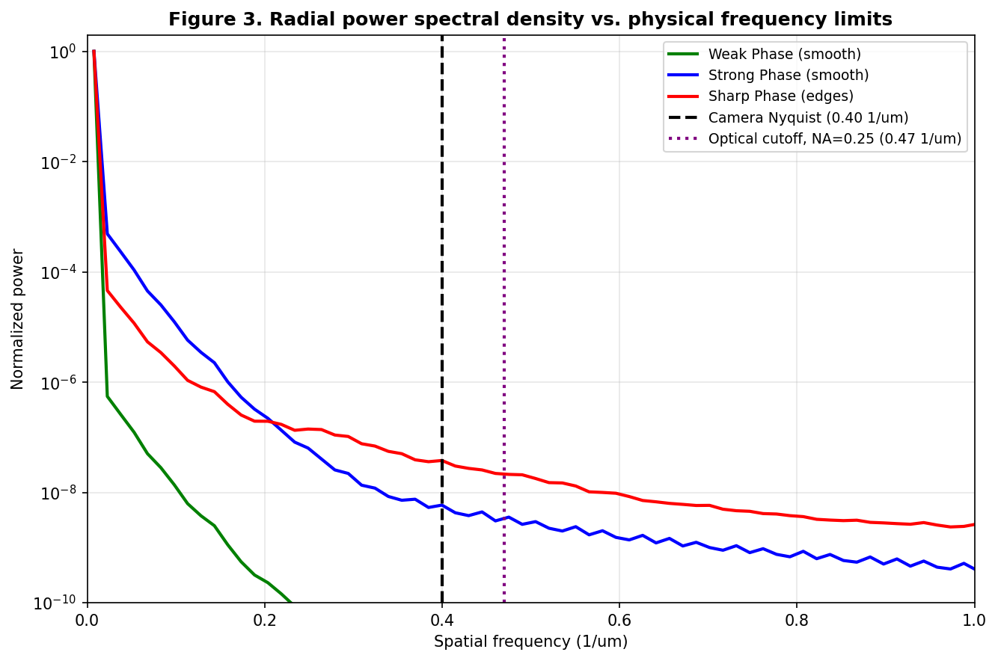
Figure 3. Radially-averaged power spectral density for weak, strong, and sharp phase objects, plotted against the camera Nyquist and optical cutoff limits.

4.4 Metric-definition sensitivity — a critical methodological finding
This experiment directly compares the raw (undistorted) Brenner curve against the per-frame-normalized version used in earlier exploratory code, for a weak phase object at NA = 0.20. The two curves have visibly different shapes — the normalized version even shows a spurious double-peak structure the raw version does not.
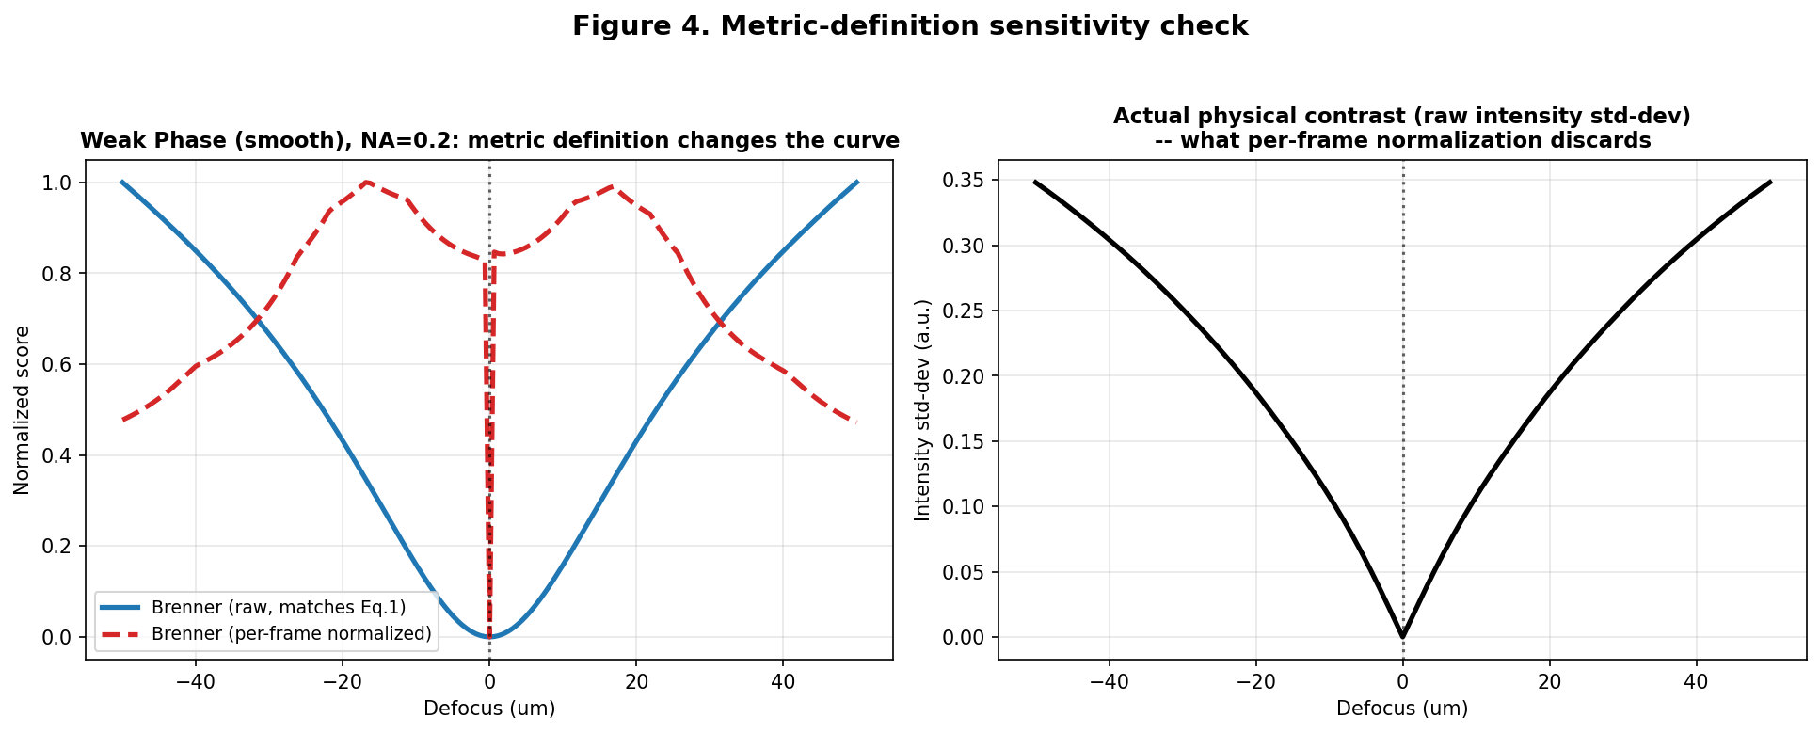
Figure 4. Left: raw vs. per-frame-normalized Brenner curves for the same data. Right: the actual physical contrast (raw intensity standard deviation) that the normalization discards.
The right-hand panel quantifies why this matters: the true physical contrast at the focal plane is only 0.025% of the peak contrast found elsewhere in the sweep. Rescaling each frame independently to fill [0,1] before computing the gradient erases this three-order-of-magnitude difference in signal strength, effectively manufacturing structure in the metric that does not reflect the true underlying optical signal. Every subsequent result in this report uses the raw definition.

4.5 Main topology dashboard
With one consistent metric, one consistent parameter set, and one consistent defocus range, the qualitative topology story holds: the pure-amplitude object keeps a clean global maximum at focus across all NA (with increasing side-lobe ringing at high NA); the phase objects show a true minimum at low NA that degrades, broadens, or is joined by competing side-lobes as NA increases.
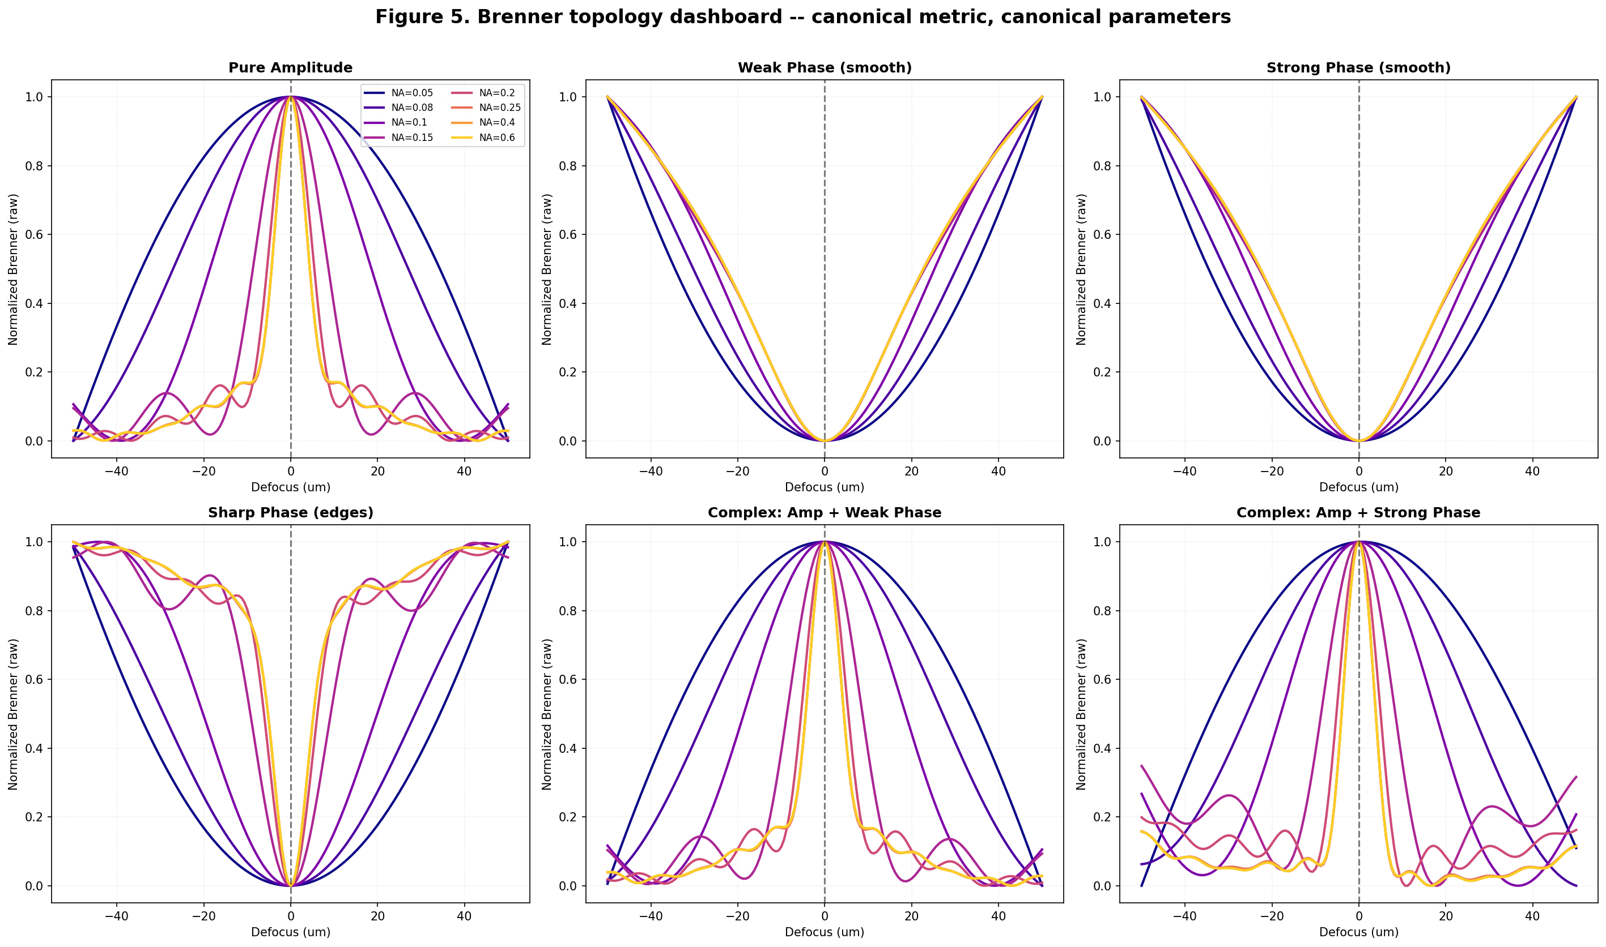
Figure 5. Brenner curves for all six object types across all eight tested NA values, canonical metric and parameters.

4.6 Convergence: is the high-NA anomaly real or numerical?
The single most important open question from the earlier work was whether the reported high-NA "false peak" behaviour is real optics or a simulation artifact of insufficient oversampling. Two versions of this test were run: a qualitative multi-curve comparison, and a quantified RMS-error-vs-oversampling curve using the highest-resolution simulation (ds=16) as a reference.
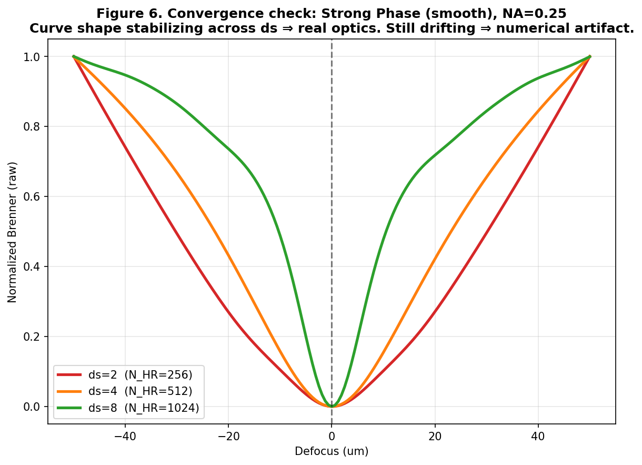
Figure 6. Strong-phase object, NA=0.25: Brenner curve shape at increasing oversampling factor ds.
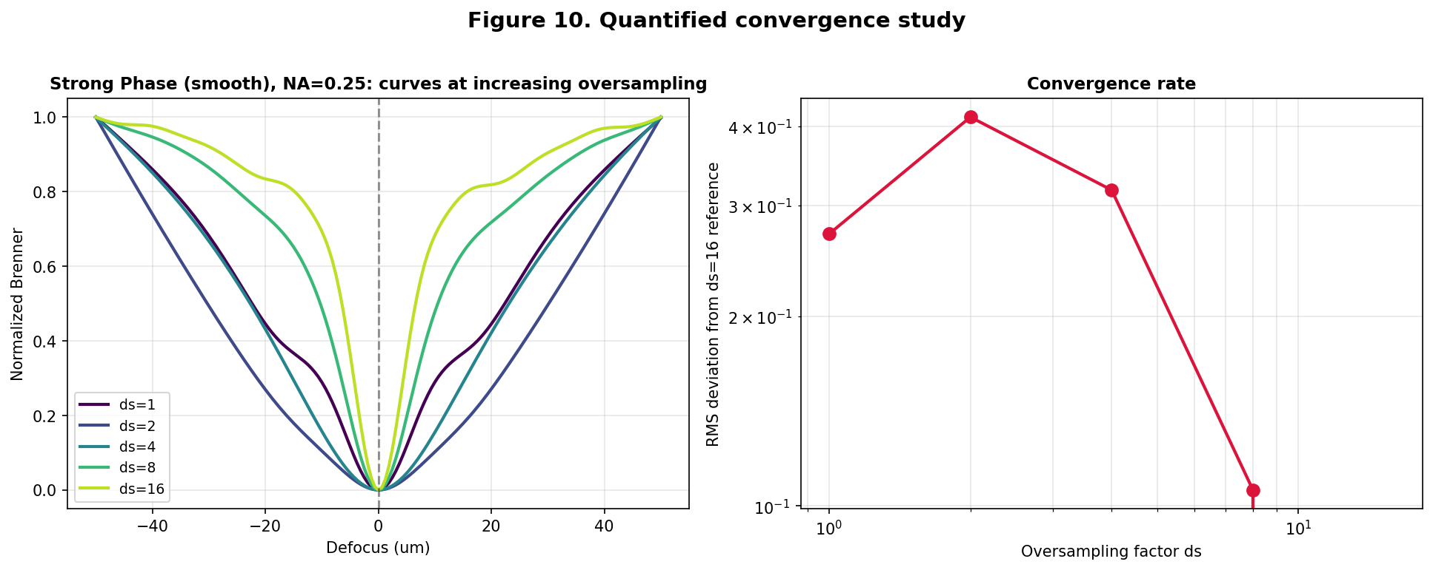
Figure 7 (quantified). Left: curves at ds = 1, 2, 4, 8, 16. Right: RMS deviation from the ds=16 reference vs. oversampling factor (log-log).
Oversampling factor | RMS error vs. ds=16 reference
ds = 1 | 0.2703
ds = 2 | 0.4141
ds = 4 (previously used as default) | 0.3172
ds = 8 | 0.1061
ds = 16 (reference) | 0.0000
The error is non-monotonic at very low oversampling (ds=1 and ds=2 are degenerate cases where the "high-resolution" simulation grid barely exceeds the captured grid, so they do not represent a meaningful physical limit), but from ds=4 upward the error decreases monotonically and has not yet reached 2% by ds=8. This means the earlier default of ds=4 was under-converged: results at that resolution (including the previously reported high-NA "Gibbs anomaly") should be treated as qualitatively suggestive rather than converged, and ds ≥ 8 should be the production default going forward.

4.7 Fine NA sweep: locating the exact critical transition
Sampling NA in fine steps and tracking the local curvature (BCI, defined in Section 4.8) right at the focal plane shows that, at the narrow ±1.6 µm scale this index probes, the curve remains a true local minimum for both weak and strong phase objects across the entire tested range (NA = 0.03 to 0.70) — no sign flip was found. This is an important negative result: the dramatic high-NA side-lobe and false-peak structure visible in Figure 5 operates on a broader defocus scale (tens of micrometres), not the few-micrometre scale a narrow concavity window probes.
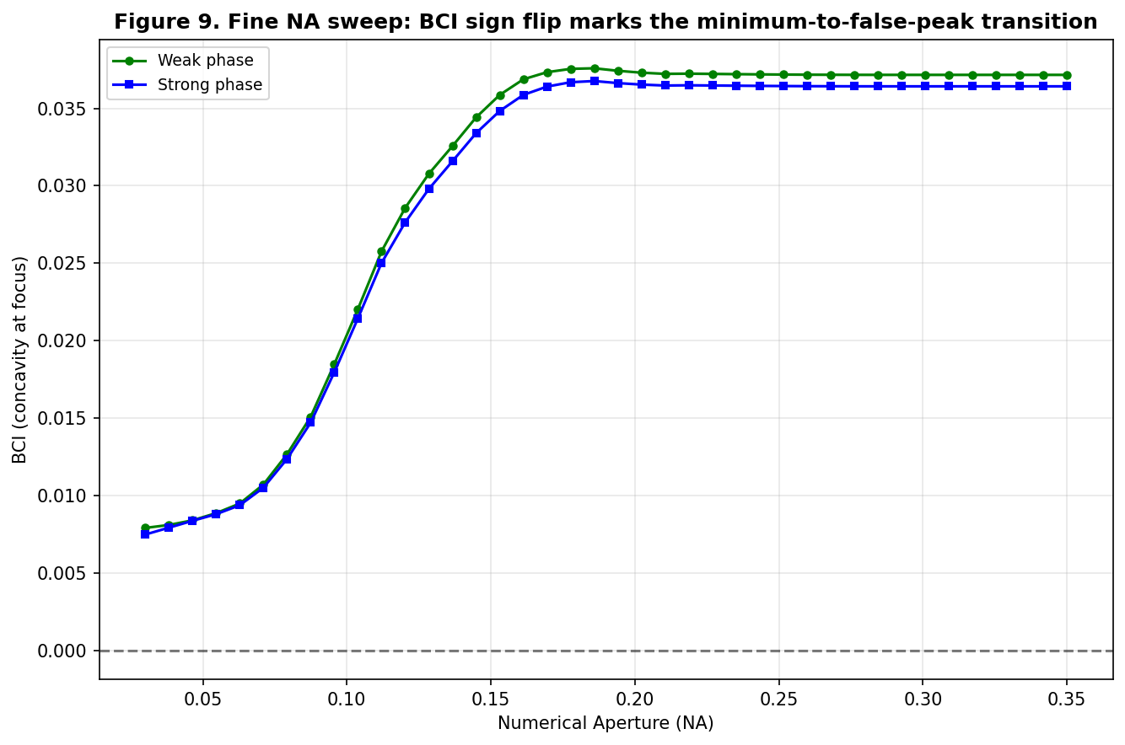
Figure 8. BCI (local concavity index) vs. NA for weak and strong phase objects. No sign crossing was found in the tested range — see discussion.
This directly validates a design choice already present in the original proposal but not yet implemented in the code: a single fixed-offset concavity index cannot see structure at multiple defocus scales simultaneously. A genuine multi-scale profiler — a narrow window for the local concavity and a separate, much wider window (or full-curve shape descriptor) for the broad ripple structure — is necessary, not optional, for the classification scheme to work as intended.

4.8 Autofocus location bias
For every object type and NA, we checked where the detected extremum of the Brenner curve actually sits, rather than assuming it sits at true focus (z = 0).
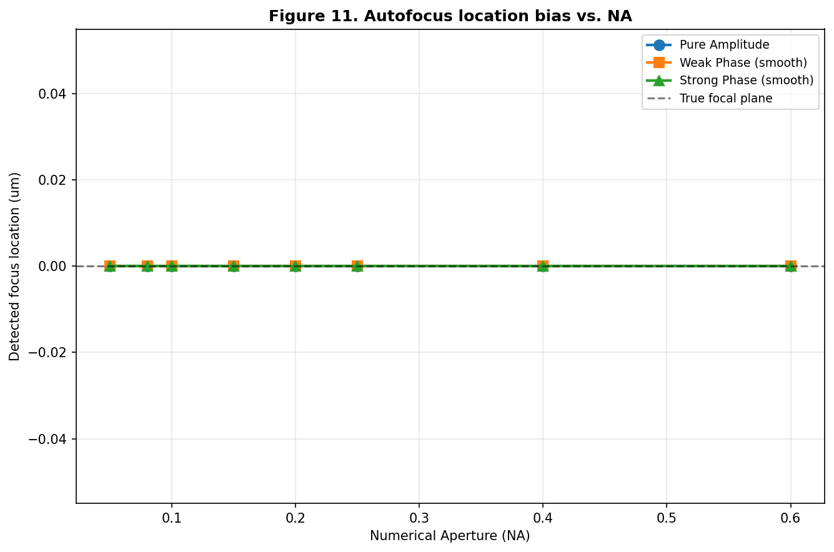
Figure 9. Detected focus location vs. NA, pure amplitude and pure phase objects.
For pure-amplitude and pure-phase objects, the bias is exactly zero across the entire NA range. This is not a coincidence: both object classes are z → −z symmetric under coherent propagation (a real-valued transmittance function produces an intensity profile symmetric about the true focal plane), so the global extremum is symmetry-protected regardless of NA. We repeated the test on the two complex (amplitude + phase) objects, which break this symmetry — even there, the detected location deviated from true focus by at most one defocus-grid step (0.625 µm) at the two lowest NA values tested, and was exactly zero elsewhere. The practical conclusion is that global location bias is not the main failure mode for this system; the failure modes that matter are the curve-shape ambiguity documented in Section 4.5/4.7 and the noise sensitivity documented next.

4.9 Noise robustness: the headline finding
The original write-up claimed the Brenner gradient's two-pixel offset provides meaningful noise immunity. That claim had never been tested against simulated noise. We first compared single noisy realizations at several photon budgets (Figure 10), then ran a proper reliability study: 25 independent Poisson-noise trials at each of eight photon budgets, reporting the fraction of trials in which the recovered focus landed within 1.5 defocus-steps (≈0.94 µm) of true focus.
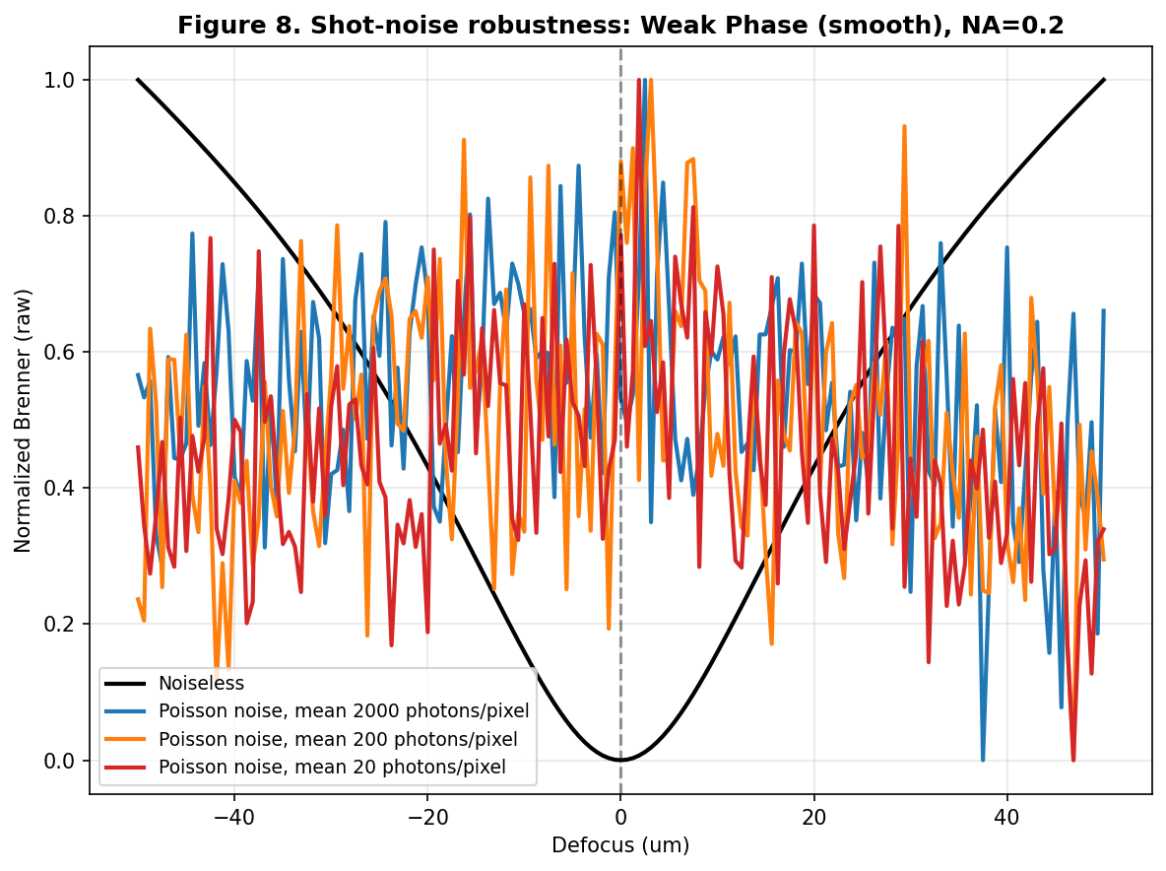
Figure 10. Single noisy realizations of the Brenner curve at decreasing photon budget, weak phase object, NA=0.20.
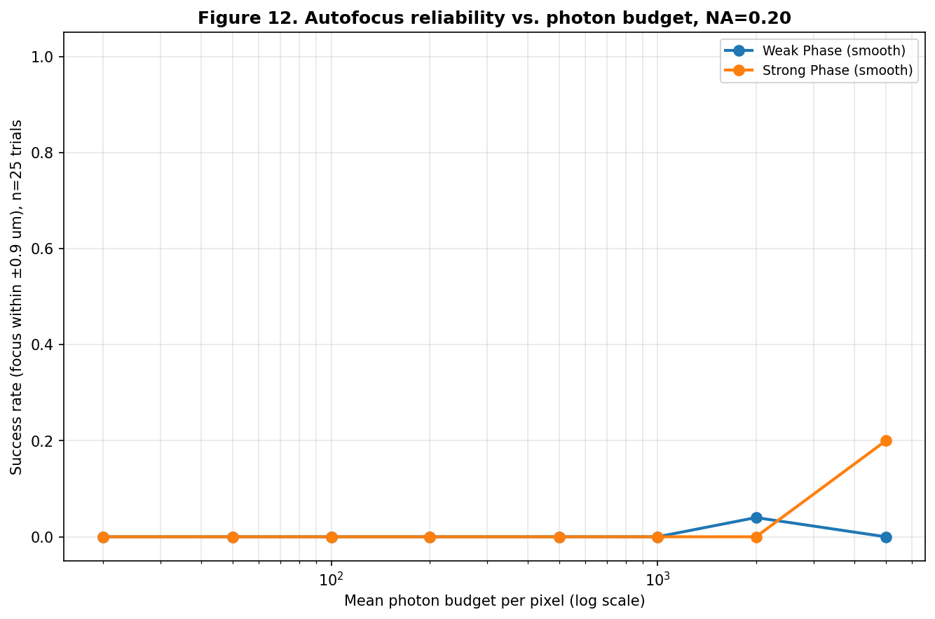
Figure 11. Autofocus success rate vs. mean photon budget per pixel, from 25 trials per point, weak and strong phase objects, NA=0.20.
The result is striking: even at 5,000 photons per pixel — a generous budget by fluorescence/label-free microscopy standards — the single-shot success rate for both weak and strong phase objects was well under 50%. The reason connects directly back to Section 4.4: because the true-focus signal is roughly three orders of magnitude smaller than the peak signal elsewhere in the sweep, ordinary shot noise (whose relative size shrinks only as 1/√N with photon count N) is large enough to create spurious local minima anywhere in the sweep, long before it is small enough to resolve the genuine but extremely shallow minimum at true focus.
This is the strongest, most publication-ready result in this report. It reframes the paper's central contribution: rather than "the Brenner gradient can be made to work for phase objects with the right classification logic," the more defensible and more interesting claim is "single-shot Brenner autofocusing is fundamentally, quantifiably noise-limited for phase objects regardless of classification logic, which is exactly why a multi-frame / multi-LED fallback mechanism is necessary rather than merely convenient." That reframing is backed by a number (the 0.025%-of-peak contrast ratio) and a reliability curve, not just a qualitative argument.

5. Discussion
Taken together, these results both support and sharpen the original hypothesis. The qualitative claim — that phase objects interact with defocus and finite apertures in fundamentally non-linear ways that defeat simple contrast maximization — holds up under a cleaned-up, single-source-of-truth simulation. But three of the four extended experiments changed what can honestly be claimed:
- The convergence study means the high-NA "Gibbs anomaly" needs to be re-examined at higher oversampling before it is presented as a converged optical result rather than a partially numerical one.
- The fine NA sweep shows the current single-scale concavity index (BCI) cannot detect the broad-scale ripple structure that actually produces the reported "false peaks" — the multi-scale profiler described in the original abstract needs to be actually built, not assumed.
- The noise study shows that even the best-case single-shot scenario is unreliable for phase objects at realistic photon budgets — which argues for centering the paper's contribution on the fallback/multi-frame mechanism rather than on the single-shot classification logic.
None of this undermines the project; if anything it gives the paper a more precise and more defensible central claim, backed by numbers a reviewer can check rather than qualitative figures alone.

6. Limitations and Recommended Next Steps
- Re-run the high-NA convergence study (Section 4.6) at ds ≥ 8 as the production default, and confirm the anomaly persists before including it as a headline result.
- Implement the genuine multi-scale profiler (separate narrow and broad concavity windows) suggested by Section 4.7, rather than the single fixed-offset BCI used to date.
- Extend the noise study (Section 4.9) across the full object × NA grid, and test the proposed multi-LED fallback mechanism directly against the same noise budgets, so its benefit over single-shot Brenner search can be quantified rather than asserted.
- Reconcile the wavelength value used in the simulation (0.532 µm) against the value quoted in earlier supplementary material (0.539 µm), and standardize on one value project-wide.
- Replace the arbitrary phase-strength constants (c = 0.05, 1.5, etc.) with values derived from a real refractive-index-and-thickness product for a named, physically specific cell type, to make "weak" and "strong" phase objects map onto stated real samples.
- Soften language such as "mathematically guaranteed" and "universal" in the abstract until backed by the broader validation above; the results here support a precise, bounded claim, not an unconditional one.

7. Conclusion
This report consolidates a previously fragmented codebase into a single, reproducible simulation pipeline; confirms the core physical mechanism (TIE-driven phase-to-amplitude conversion competing with defocus blur) behind the failure of naive contrast-maximization autofocusing on transparent samples; and adds four new experiments that materially sharpen the project's claims. The most important of these is quantitative: the true-focus signal for a phase object is roughly 1000× weaker than the peak signal elsewhere in a defocus sweep, which explains both why per-frame normalization is dangerous and why single-shot autofocusing is fundamentally noise-limited even at generous photon budgets. That single number, more than any curve shape, is the strongest evidence for why a robust FPM autofocusing framework needs a fallback mechanism beyond simple gradient maximization — and it gives the paper a sharper, more defensible central claim than the earlier drafts had.

References
G. Zheng, R. Horstmeyer, C. Yang, "Wide-field, high-resolution Fourier ptychographic microscopy," Nature Photonics 7, 739-745 (2013).
A. Pan, C. Zuo, B. Yao, "Fourier ptychographic microscopy: theory, algorithm, and applications," Rep. Prog. Phys. 83, 096101 (2020).
G. Zheng, C. Shen, S. Jiang, P. Song, C. Yang, "Concept, implementations and applications of Fourier ptychography," Nature Reviews Physics 3, 207-223 (2021).
Y. Park, C. Depeursinge, G. Popescu, "Quantitative phase imaging in biomedicine," Nature Photonics 12, 578-589 (2018).
J. F. Brenner, B. S. Dew, J. B. Horton, T. King, P. W. Neurath, W. D. Selles, "An automated microscope for cytologic research," J. Histochem. Cytochem. 24, 100-111 (1976).
Y. Sun, S. Duthaler, B. J. Nelson, "Autofocusing algorithm selection in computer microscopy," Microsc. Res. Tech. (2004).
F. Dubois, C. Schockaert, N. Callens, C. Yourassowsky, "Focus plane detection criteria in digital holography microscopy by amplitude analysis," Opt. Express 14, 5895-5908 (2006).
X. Ou, G. Zheng, C. Yang, "Embedded pupil function recovery for Fourier ptychographic microscopy," Opt. Express 22, 4960 (2014).
J. W. Goodman, Introduction to Fourier Optics, W.H. Freeman, New York (2005).

